Easy English Participant Information Sheet
Project: Development and testing of an educational intervention for delivery of Cardiopulmonary Resuscitation and Basic Life Support to people who use a wheelchair.

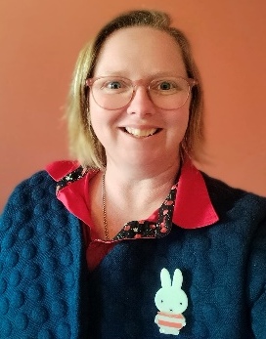
Hello my name is Elisha
I am a researcher
I have some questions and
I want your help
Elisha has a person called Nathan helping her

Elisha is wanting to talk to people who use a wheelchair
She also wants to talk to their carers or family

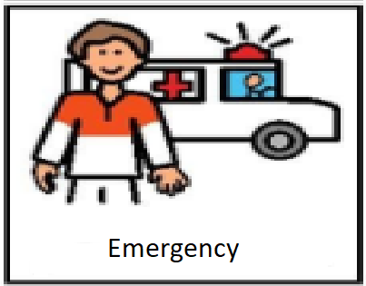

Elisha wants to ask questions about emergency health care
She wants to know about how you have received emergency care

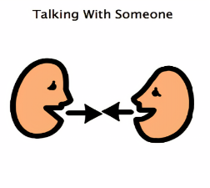
Elisha will want to have a talk with you
She will ask to record the talk
Elisha will listen to the recording later
She is the only person who will listen

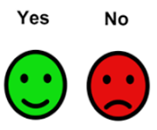
Elisha will ask some questions
You can choose if you want to answer
You can stop anytime you want

The talk should take about 1 hour
The talk might be online, on the phone or face to face
We can decide together when and where to talk

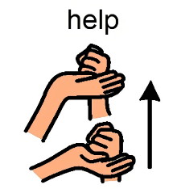
Having a talk with Elisha might help
carers, family and health professional look
after you and other people better in future.
But there is no benefit straight away.

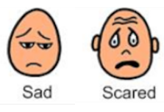
Having a talk with Elisha might make you think
About things that have happened to you
It might make you feel sad or scared
You can bring someone with you to the talk

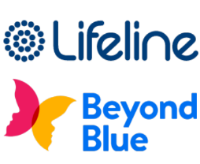
If you feel sad or scared after the
interview you can talk to someone you know or
Contact Life line – 13 11 14
or BeyondBlue – 1300 224 636 or www.beyondblue.org.au/getsupport

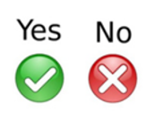
After Elisha has listened to the talk
She will send you a copy to check
that she got things right.

After Elisha has finished talking to people
she will write a paper and tell other people
about the study and what she found out.

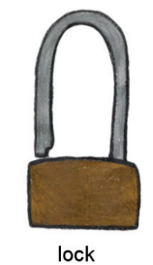
All the information you give Elisha
will be locked away for 5 years.
Then it will be destroyed.

If you change your mind about
being in the study you can tell Elisha or Nathan
and they will destroy your information straight away
Elisha – Email - 22061159@student.westernsydney.edu.au
Nathan – Email – n.wilson@westernsydney.edu.au

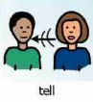
If you know someone else who would like to
talk to Elisha it is ok to share her details

Anyone who wants to know about the study can
Email Elisha – 22061159@student.westernsydney.edu.au
and she will contact them.

If you or anyone else has questions about the study
Contact: Elisha – the researcher – 22061159@student.westernsydney.edu.au
OR Nathan – Supervisor – n.wilson@westernsydney.edu.au

If you want to tell someone that something went wrong
or make a complaint
Contact: Ethics Committee through Research Engagement, Development and Innovation (REDI) on Tel +61 2 4736 0229 or email humanethics@westernsydney.edu.au

They won’t tell anyone that you contacted them
But they will investigate the problem
The information Elisha collects may be personal health information
Elisha must follow all the University rules about collecting and using your information
The University has a Privacy Policy and a Privacy Management Plan
Privacy
If you want to read more you can at https://www.westernsydney.edu.au/footer/privacy

This information is for you to keep, the consent form is kept by Elisha.

This study has been approved by Western Sydney University Human Research Ethics Committee. The Approval number is H15709

