Participation Information Statement

Project title: Co-designing a psychoeducation package to enhance psychosocial wellbeing for young adults living with stroke

- What is this project about?
We are developing resources and methods of providing information to young stroke survivors and their support people about common invisible difficulties (such as difficulties with fatigue, mood and thinking skills).

We want your opinion on what topics the resources should cover, and how it might be helpful to receive this information.

We aim to include people from all over Australia.

You are invited to participate because you had a stroke in the last 5 years, and were aged 18-45.

This Participant Information Sheet and Consent Form tells you about the research project. You can then decide if you want to take part.
Please read this document. It is formatted to be easy for people with communication and cognitive difficulties to read and understand.
Ask questions about anything that you don’t understand or want to know more about. You might want to talk about it with a relative, friend or local doctor.
Participation is voluntary.
If you want to take part in the research project, you will be asked to sign the consent form. By signing it you are telling us that you:
- Understand what you have read
- Consent to take part in the research
- Consent to the project discussions described

- Who is conducting this study?
Associate Professor Dana Wong
La Trobe University
Ms Michaela Grech
La Trobe University
Dr Toni Withiel  Royal Melbourne Hospital | 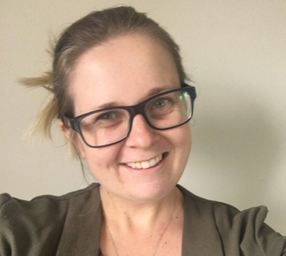
Associate Professor Emma Power
University of Technology, Sydney
Professor Ian Kneebone
University of Technology, Sydney
Associate Professor Rene Stolwyk  Monash University | 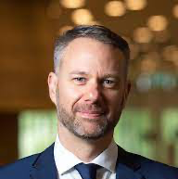
Dr Eirini Kontou
University of Nottingham, United Kingdom
Mr Adrian O’Malley
Physical Disability Council of New South Wales
The project has been funded by the Tim Glendinning Memorial Grant through the Stroke Foundation. | 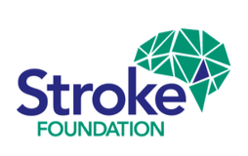

- What will this study involve?
There are 2 stages in this project.
In Stage 1 you will attend an online discussion. You will help to decide what things are important to include in an information package to support young stroke survivors.

After this discussion, the researchers will develop examples of these resources.

In Stage 2, you will attend another online discussion to talk about these examples.

If you have communication difficulties: we can help you to understand the survey or provide your thoughts.
Each stage will take around 90 minutes.

We will record these conversations with your permission.

You can continue with your usual lifestyle and care throughout this project.

You will be paid $50 per hour for the time you spend on this project.

- Do I have to take part in this study?
Participation in this study is voluntary and you can withdraw at any time
Stopping will not affect your current or future treatment, research involvement or relationship with your care team.

- Are there any risks or costs associated with this study?
There is a risk that you may find some of the questions stressful or upsetting. You can skip these questions, take a break, or stop immediately. If this happens, we will offer you support.

There are also several services you can contact for additional support:

Helpline | Helpline phone number | Hours available | About the helpline
Stroke Foundation | 03 9670 1000 | Monday to Friday,  9am to 5pm | First point of call when dealing with a distressed stroke survivor or relative.
Stroke Foundation StrokeLine | 1800 787 653 | Monday to Friday, 9am to 5pm. | Information and advice on stroke prevention, treatment, recovery, and support.
Carers Australia | 1800 242 636 | Monday to Friday, 8:30am to 4:30pm | Provides information and counselling to carers.

- What are the possible benefits?
We cannot promise you any benefits from this research.

But you may feel good after talking with others and helping to improve the resources that are provided to other young stroke survivors in the future.

- What will happen to information about me?
We will store your information securely for at least 7 years. Only the research team can read the information.

The information you provide will remain confidential. We will not use your name or identify you in any way.

You have the right to access your information.

If you withdraw, any information that you have provided will be retained.

- Will I hear about the results of the study?
We will send you a summary of the results after each group discussion to check that it is accurate.

We will send you a copy of the project report at the end of the project.

- Research compliance
Research involving humans in Australia is reviewed by an independent group of people on a Human Research Ethics Committee (HREC).
This study has been approved by the HREC of La Trobe University.
If you are concerned about the way this study is being conducted or you wish to make a complaint about any part of this study, please contact the La Trobe Human Ethics Committee:
Ethics and Research Governance Manager Phone: 03 9479 1443
Email: humanethics@latrobe.edu.au

- Further information and who to contact
Michaela Grech can discuss the study with you at any time.
Phone: 0426 267 177
Email: m.grech@latrobe.edu.au

Associate Professor Dana Wong can also discuss the study with you
Phone: 03 9479 5079
Email: d.wong@latrobe.edu.au

Declaration by Participant

Yes, I would like to participate

Name of Participant: __________________________________________________

Signature: _____________________________ Date: ________________________

I am happy for information collected for this research to be used in future related studies

- Yes

- No

Name of Participant: __________________________________________________

Signature: _____________________________ Date: ________________________

Declaration for participants unable to read the information and consent form

Witness* to the informed consent process.

Name (please print): __________________________________________________

Signature: _____________________________ Date: ________________________

- Witness is not to be the investigator, a member of the study team or their delegate. Wittness can be a support person (e.g., family member, friend or paid carer) aged 18 years or older.

