Participant Information Sheet

Title | Establishing an intensive, high dose, stroke recovery student led clinic to improve upper limb outcomes
Short Title | A burst of intensive treatment for stroke recovery
Project Number | 204507
Chief Investigators | Brenton Hordacre, Jeric Uy, Susan Hillier, Saran Chamberlin

Introduction – What does my participation involve?
You are invited to take part in this research project. You have been invited because you have previously had a stroke. The research project is evaluating the delivery of an intensive, high-dose, burst of treatment for arm recovery delivered by physiotherapy students at UniSA.

This Participant Information Sheet tells you about the research project. It explains the tests and treatments involved. Knowing what is involved will help you decide if you want to take part in the research. Please read this information carefully. Ask questions about anything that you don’t understand or want to know more about. Before deciding whether or not to take part, you might want to talk about it with a relative and/or friend.

Participation in this research is voluntary. If you don’t wish to take part, you don’t have to. Your regular healthcare will not be affected by your decision to participate or not. If you decide you want to take part in the research project, you will be asked to sign a consent form. By signing it you are telling us that you:
• Understand what you have read
• Consent to take part in the research project
• Consent to have the tests and treatments that are described
• Consent to have the use of your information as described.

You will be given a copy of this Participant Information and Consent Form to keep.

What is the purpose of this research?
We are particularly interested in new ways of helping people with stroke recover use of their arm given many people who survive stroke endure ongoing disability related to poor arm movements. Currently, clinical services simply do not provide enough therapy to support meaningful levels of recovery. Typically, patients might receive a weekly training session that goes for 45 minutes to 1hr. While this might lead to some improvement after many sessions, current evidence has shown that large and persisting improvements can be achieved, even years after stroke, by delivering intensive, high-doses of training.

The aim of this study is to evaluate a burst of intensive, high-dose, training for arm recovery after stroke through a student led physiotherapy clinic. Specifically, we are interested in understanding how effective this treatment approach might be, if it is possible for the student clinic to continue to offer this model of care, whether people achieve meaningful improvements, whether it is safe and who it might be best suited for.

Eligibility
To be able to participate in this study, you will need to be over 18 years of age, have a history of stroke and be medically stable. We are also looking for people with any level (mild to severe) of upper-limb impairment.
You will not be able to participate in this study if:
- You have a history of another neurological disease e.g. Parkinson’s Disease
- If you are unable to provide consent (e.g. cognition problems)
- You are currently undertaking rehabilitation for your upper limb

What does participation in this research involve?
To ensure you meet the above eligibility criteria, there will be a screening process. Where possible, this will be completed via the phone and include questions regarding your stroke, ability to move or use your arm and your level of cognition. The time required to complete this screening is approximately 10-20 minutes. In some instances, where it is not clear whether you meet the inclusion criteria, you may be required to come to the university for an in-person assessment of your arm movement. This will take ~15 minutes and will be conducted at a time that best suits you. You should be aware that if these assessments determine that you are not eligible, then you will be unable to take part in this research. If you are eligible and choose to participate, written consent (signed consent form) will be required prior to participate.

You will be participating in a randomised study. This means, if you choose to participate, you may be randomly allocated to a wait-list group or to the intervention. This random allocation will be done using a computer. Your specific allocation will be concealed prior to enrolment in the study and also during collection initial outcome measures. Those in the wait-list group will simply wait five weeks before being invited to participate in the intervention part of the project. The advantage of this approach is that all participants enrolled into this study will have the opportunity to undertake the intervention (an intensive, high-dose, burst of training). It is important to note that the burst of training will be delivered through the physiotherapy student clinic. Third year physiotherapy students will be involved in delivering the treatment under supervision of a qualified clinician. Outcomes from before and after the intervention will be compared to the outcomes in the wait-list group.

During the intervention phase of the project, you will be asked to attend the UniSA City West Health and Medical Clinic for 3 occasions per week for treatment to help your arm recover. This treatment will be tailored to you and include traditional physiotherapy, exercise classes, new technologies (e.g. gaming devices, robotics, see figure 1) and a home exercise program. In total, you will be completing 90 hours of therapy over the 5 week period. This will be comprised of 18 hours of treatment per week. Although tailored to each person, this is approximately achieved by three 1.5hr sessions of task specific training with a physiotherapy student, three 1.5hr sessions of technology-based rehabilitation, three 1hr exercise group classes and a 6-day a week home exercise program (1hr per day).

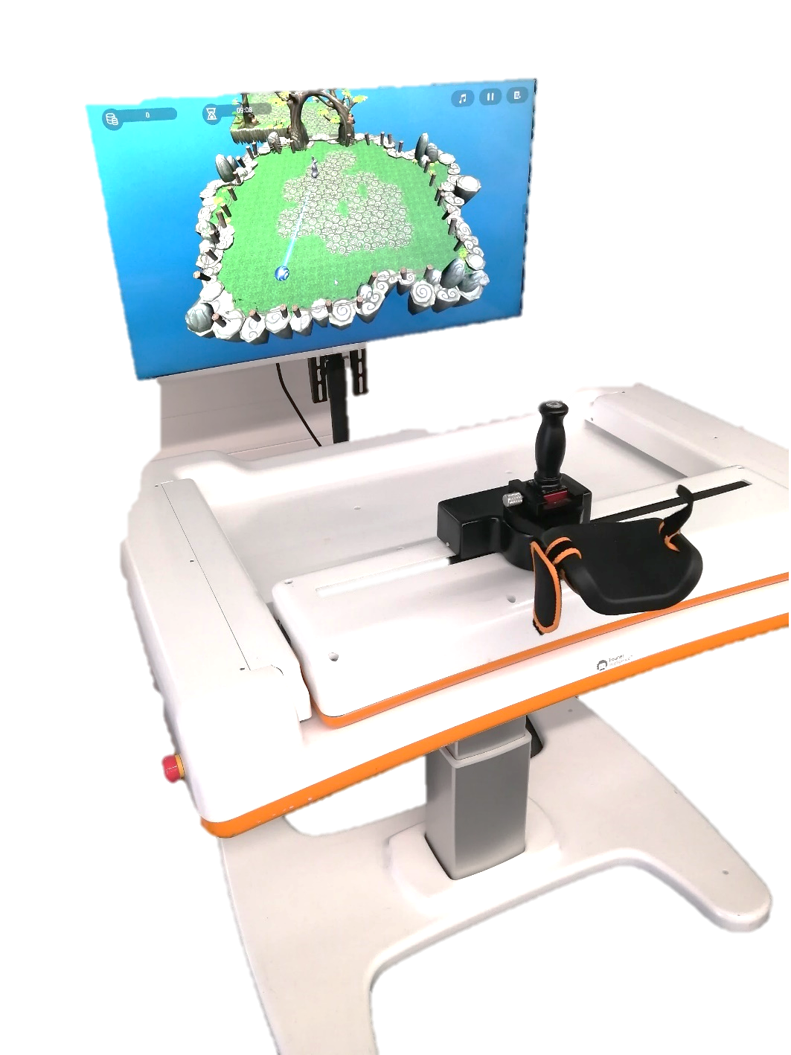
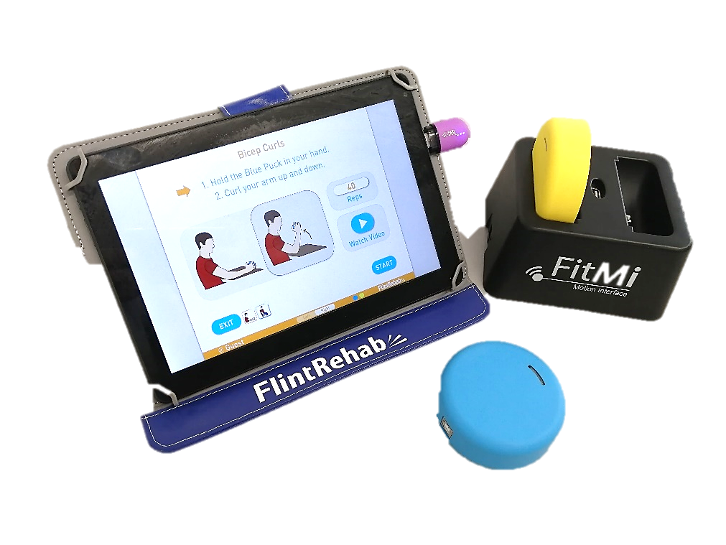
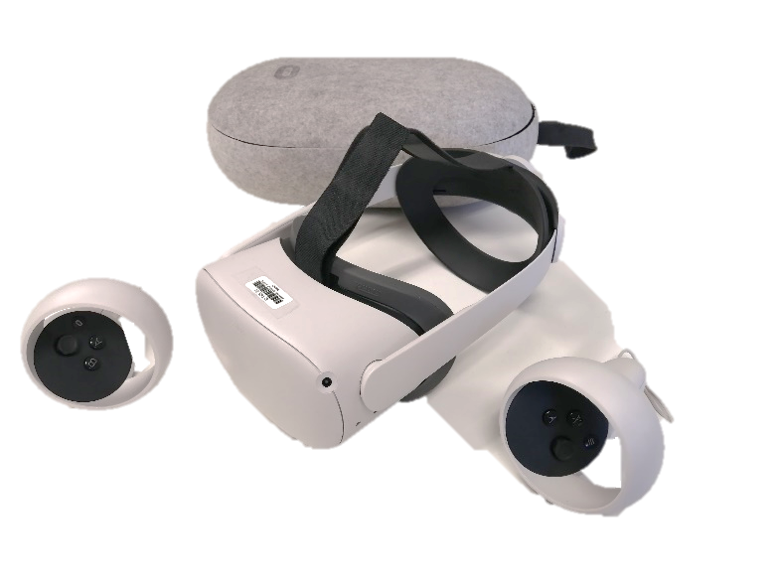
At the start of the program, you will be asked to fill out an information sheet that will provide us of details of your age, sex, stroke side, date of stroke and dominant hand side. We will also perform a brief assessment using transcranial magnetic stimulation. Briefly, this assessment is an indicator of the connection between the brain and hand. It involves placing some sticker-like electrodes on your affected hand, and then applying electromagnetic pulses to the brain. This is a safe and painless procedure that feels like someone is mildly tapping the surface of your scalp. We have performed this procedure many times and all participants will be screened to ensure they are safe for this assessment. Knowing all this information is important as it helps us know who we can apply the results to at the conclusion of this study. This will take approximately 20-30 minutes to complete.

Figure 1: Examples of the technologies used in rehabilitation. Top left) Virtual reality, Bottom left) gaming device on a tablet, Right) An arm robotic gaming device.

At the beginning and end of this 5 week treatment period, we will obtain some measures to understand the possible benefit of this program. Briefly, these outcome measures will include the following;
- A measure of upper-limb impairment and activity (~15 minutes duration)
- A measure of self-efficacy (the belief you can manage everyday activities; ~5 minutes)
- A measure of quality of life (~10 minutes)

Furthermore, we will obtain some additional outcomes following the treatment phase only (ie not before the treatments). These are;
- Document any identified adverse events (~5 minutes)
- Questionnaires to understand your experience in the program (response on a scale of 1-5, ~10 minutes)
- Information regarding hospital visits, emergency department visits, aged care system use and employment information (by short interview at the conclusion of the study). This will take ~ 20 minutes and can be conducted either in-person or via Zoom/Skype/Telephone (or similar) depending on your preference.
- A brief interview to understand your experience and perspective with the program (approx. 30 minutes). This interview will be voice recorded and can be completed either in person, over the phone or online, depending on your preference.

The wait-list control group will not perform rehabilitation exercises but will have the same outcomes measure of upper limb impairment and activity, quality of life and self-efficacy at the start and end of the 5 week period.

There is free parking available in Gray Street where the entrance to the clinic is located and an access drop-off point at the front door. Furthermore, the Royal Adelaide Hospital (across the road from the clinic) also provides 2hrs free parking for people with disabled permits. As usual with all our clinical services, you are welcome to bring a family member or carer with you to any of the sessions.

What are the possible benefits of taking part?
Participants in this study will receive 5 weeks of upper-limb rehabilitation therapy at no cost. However, it should be noted that we cannot guarantee improvements in upper limb ability.

What are the possible risks and disadvantages of taking part?
People in this study will likely perform much greater and more intense use of their affected arm than they may have since experiencing the stroke. As a result, some participants might experience mild and transient muscle soreness, similar to that experienced by people who attend a gym session.

It is also possible some people may experience mild and temporary symptoms from the brain stimulation measure. These might include a mild headache or discomfort.

There may be side effects that the researchers do not expect or do not know about and that may be serious. Tell your study investigator immediately about any new or unusual symptoms that you get. We will also ask you about any symptoms during the treatment and at the conclusion of the study.

If side effects occur during the intervention, the intervention may need to be ceased. If side effects are severe, the investigator will get medical help.

Do I have to take part in this research project?
Participation in any research project is voluntary. If you do not wish to take part, you do not have to. If you decide to take part and later change your mind, you are free to withdraw from the project at any stage.

If you do decide to take part, you will be given this Participant Information and Consent Form to sign and you will be given a copy to keep.

Your decision whether to take part or not to take part, or to take part and then withdraw, will not affect your routine treatment, your relationship with those treating you or your relationship with the University. Please note, however, that should you choose to withdraw from the study, you have until one month after the completion of your involvement to request that this data be removed from the study

What will happen to information about me?
All data collected from you and about your participation in the research will be coded to protect your confidentiality and only members of the research team will be able to link results to your personal details. At the completion of the project, data will be securely stored in a non-identifiable format on the UniSA server, password protected computers and in locked filing cabinets at the UniSA City East Campus. This information will be stored for at least 15 years after the completion of the project (in line with University policies for clinical trial research). All records containing personal information will remain confidential and no information which could lead to the identification of any individual will be released, unless where this is required by law.

Please also note that non-identifiable data collected in this project may be used as comparative data in future projects, for which ethics approval will be sought.

What if something goes wrong?
Standard first-aid procedures will be applied. All staff are trained to apply immediate first-aid.

What happens when the research project ends?
A summary of the project results will be available at the completion of this study (intended to be April 2024). This will be communicated to you via email or post.

With your consent, your demographic and contact details will be stored in a secure database so that you may be contacted regarding involvement in potential future studies (for which further ethical clearances will be obtained). Please note that this consent can be removed at any point in the future by discussion with the research team

Who is organising and funding the research?
This research project is being conducted by Dr Brenton Hordacre, Dr Jeric Uy and Professor Susan Hillier from the University of South Australia. This research was funded by the Hospital Research Foundation. Whilst the Hospital Research Foundation have provided funding for the project in providing $80,000 and have an interest in the outcome of the research, the study has been designed independently by researchers from the University of South Australia and the study protocol and results will in no way be influenced by the Hospital Research Foundation. Results will be presented at group-level and in a non-identifiable format.

Who has reviewed the research project?
The ethical aspects of this research project have been approved by the Human Research Ethics Committee (HREC) of the University of South Australia as required by the Australian government research requirements, specified in the National Statement on Ethical Conduct in Human Research (2007 - updated 2018). This statement has been developed to protect the interests of people who agree to participate in human research studies.

Further information and who to contact
The person you may need to contact will depend on the nature of your query. If you want any further information concerning this project or if you have any problems which may be related to your involvement in the project, you can contact the researcher on [Phone number] or any of the following people:

Research contact person
Name | Brenton Hordacre
Position | Senior Researcher
Telephone | 83021286
Email | Brenton.hordacre@unisa.edu.au

If you have any complaints about any aspect of the project, the way it is being conducted or any questions about being a research participant in general, please contact:

Reviewing HREC name | University of South Australia Human Research Ethics Committee
Telephone | +618 8302 6330
Email | humanethics@unisa.edu.au
Reviewing HREC approving this research and HREC Executive Officer details

COVID-19 Safety
Please note, COVID safety measures will be implemented during the data collection process. This will include hand washing procedures, implementing physical distancing where possible, disinfecting all equipment between each experiment, the use of personal protective equipment and screening all participants.

